

GROUP NAME- CLOUDQUANT SYNDICATE

**PROJECT-2**

**Hosting HTML, CSS, and JS** **Website in AWS**

**SUBMITTED BY:- SUBMITTED TO:**

**SHUBH GUPTA ABHINAV SIR**

**BCA SEMESTER-4**

***Topics :***

* [Step 1: Create a bucket](https://docs.aws.amazon.com/AmazonS3/latest/userguide/HostingWebsiteOnS3Setup.html" \l "step1-create-bucket-config-as-website" \o "https://docs.aws.amazon.com/AmazonS3/latest/userguide/HostingWebsiteOnS3Setup.html#step1-create-bucket-config-as-website)
* [Step 2: Enable static website hosting](https://docs.aws.amazon.com/AmazonS3/latest/userguide/HostingWebsiteOnS3Setup.html" \l "step2-create-bucket-config-as-website" \o "https://docs.aws.amazon.com/AmazonS3/latest/userguide/HostingWebsiteOnS3Setup.html#step2-create-bucket-config-as-website)
* [Step 3: Edit Block Public Access settings](https://docs.aws.amazon.com/AmazonS3/latest/userguide/HostingWebsiteOnS3Setup.html" \l "step3-edit-block-public-access" \o "https://docs.aws.amazon.com/AmazonS3/latest/userguide/HostingWebsiteOnS3Setup.html#step3-edit-block-public-access)
* [Step 4: Add a bucket policy that makes your bucket content publicly available](https://docs.aws.amazon.com/AmazonS3/latest/userguide/HostingWebsiteOnS3Setup.html" \l "step4-add-bucket-policy-make-content-public" \o "https://docs.aws.amazon.com/AmazonS3/latest/userguide/HostingWebsiteOnS3Setup.html#step4-add-bucket-policy-make-content-public)
* [Step 5: Configure an index document](https://docs.aws.amazon.com/AmazonS3/latest/userguide/HostingWebsiteOnS3Setup.html" \l "step5-upload-index-doc" \o "https://docs.aws.amazon.com/AmazonS3/latest/userguide/HostingWebsiteOnS3Setup.html#step5-upload-index-doc)
* [Step 6: Configure an error document](https://docs.aws.amazon.com/AmazonS3/latest/userguide/HostingWebsiteOnS3Setup.html" \l "step6-upload-error-doc" \o "https://docs.aws.amazon.com/AmazonS3/latest/userguide/HostingWebsiteOnS3Setup.html#step6-upload-error-doc)
* [Step 7: Test your website endpoint](https://docs.aws.amazon.com/AmazonS3/latest/userguide/HostingWebsiteOnS3Setup.html" \l "step7-test-web-site" \o "https://docs.aws.amazon.com/AmazonS3/latest/userguide/HostingWebsiteOnS3Setup.html#step7-test-web-site)
* [Step 8: Clean up](https://docs.aws.amazon.com/AmazonS3/latest/userguide/HostingWebsiteOnS3Setup.html" \l "getting-started-cleanup-s3-website-overview" \o "https://docs.aws.amazon.com/AmazonS3/latest/userguide/HostingWebsiteOnS3Setup.html#getting-started-cleanup-s3-website-overview)

# *Prerequisites :*

**- *AWS account***

***- HTML/CSS/JS files ready***

***- AWS CLI or access to AWS Console***

# Step 1: Create an S3 Bucket

1. Go to the AWS S3 Console Sign in to the AWS Management Console and open the Amazon S3 console at [https://console.aws.amazon.com/s3/](https://console.aws.amazon.com/s3/" \o "https://console.aws.amazon.com/s3/).
2. Click 'Create bucket'.

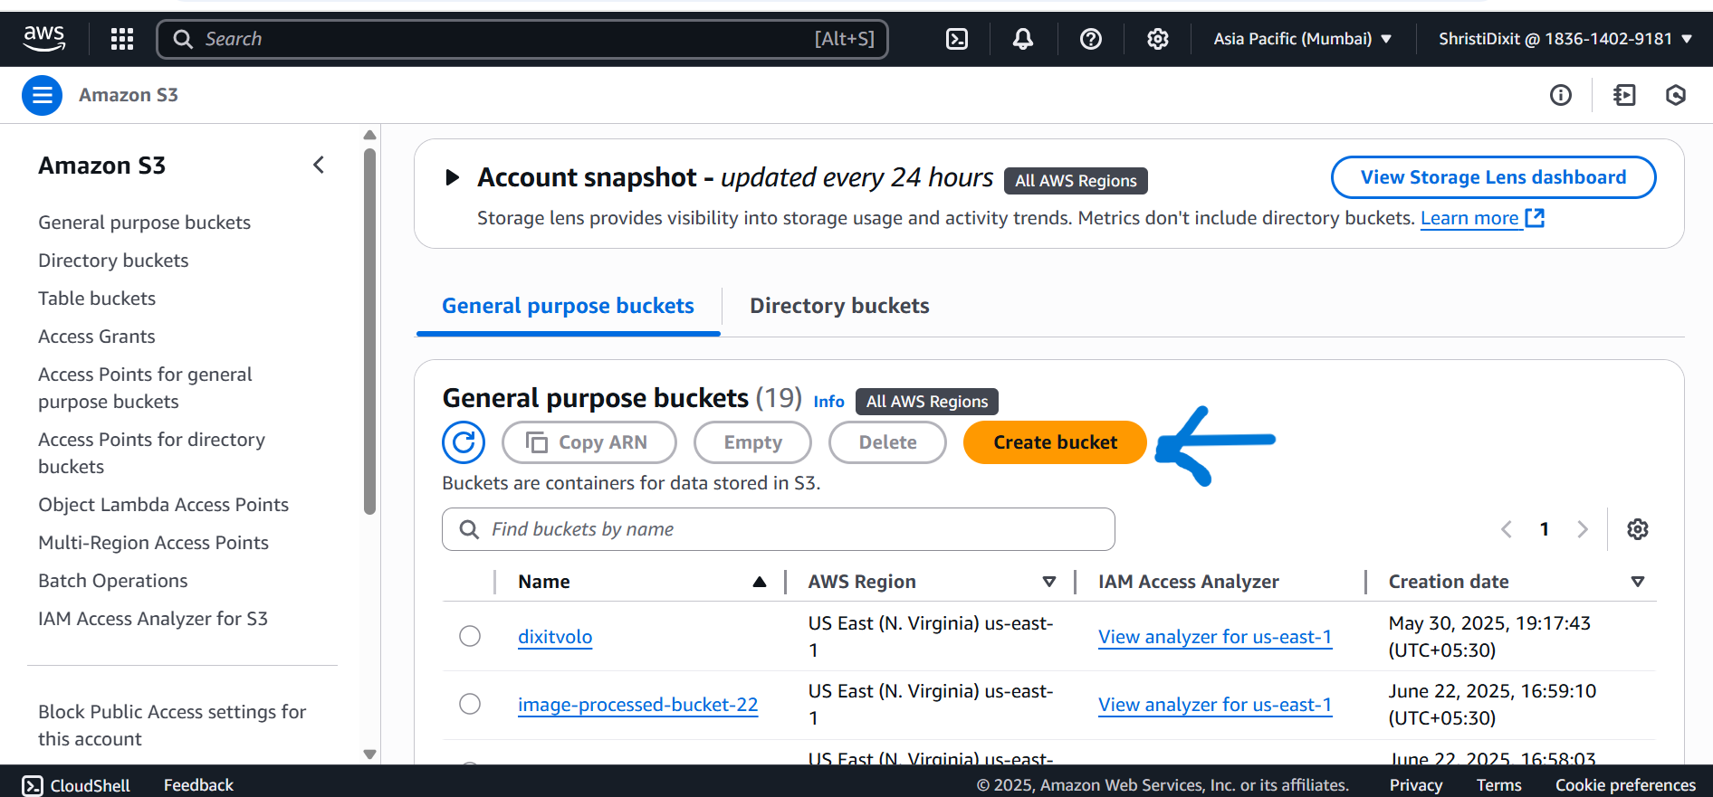

3. Enter a unique bucket name (e.g., my-website-bucket)

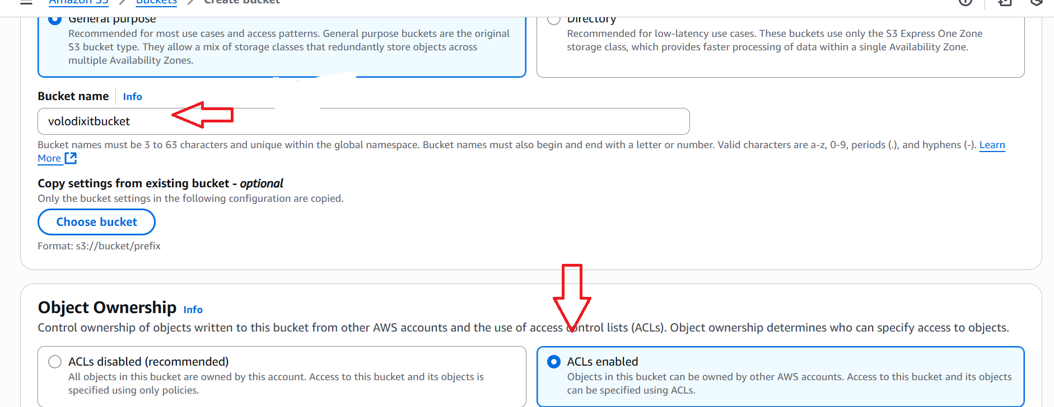

1. Region: Choose a region close to you.

5. Uncheck 'Block all public access'.

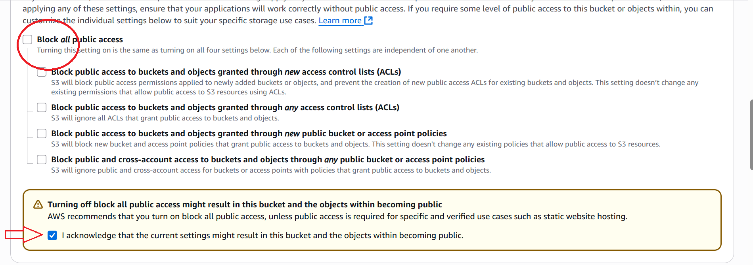

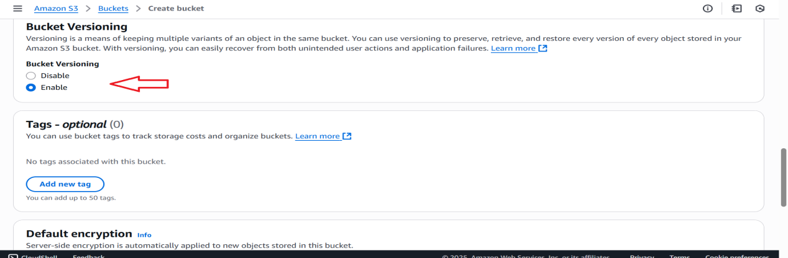

1. Click 'Create bucket'.

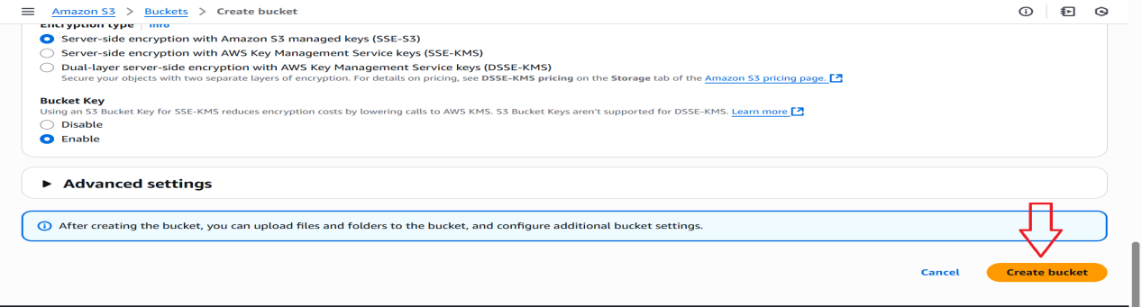

# Step 2: Upload Your Website Files

1. . Click on your new bucket.

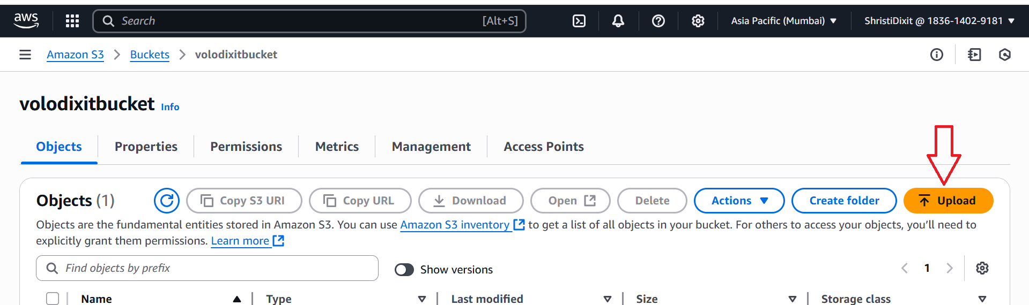

2. Click 'Upload', then drag & drop your HTML/CSS/JS files.

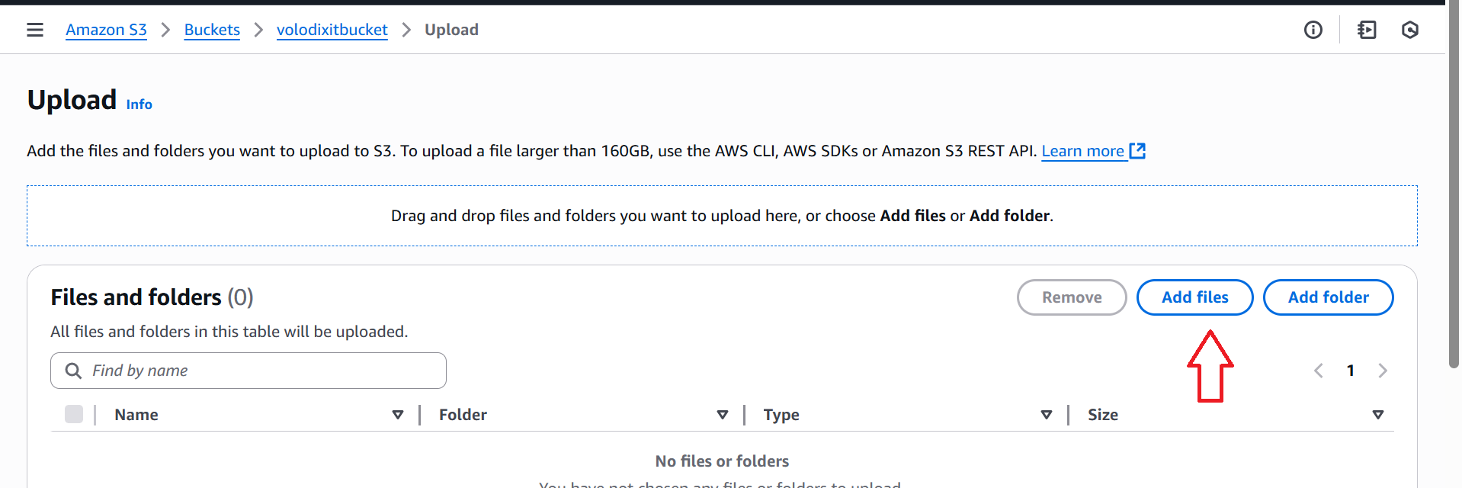

In **Index document**, enter the file name of the index document, typically index.html.

The index document name is case sensitive and must exactly match the file name of the HTML index document that you plan to upload to your S3 bucket. When you configure a bucket for website hosting, you must specify an index document. Amazon S3 returns this index document when requests are made to the root domain or any of the subfolders.

1. To upload the index document to your bucket, do one of the following:
   * Drag and drop the index file into the console bucket listing.
   * Choose **Upload**, and follow the prompts to choose and upload the index file.

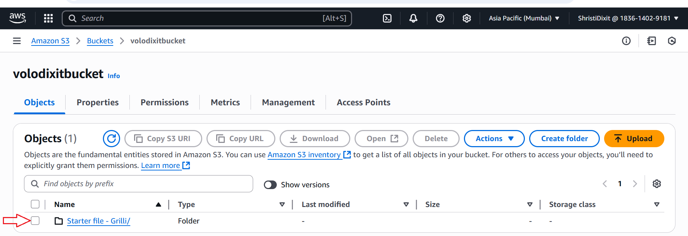

3. Click 'Upload'.

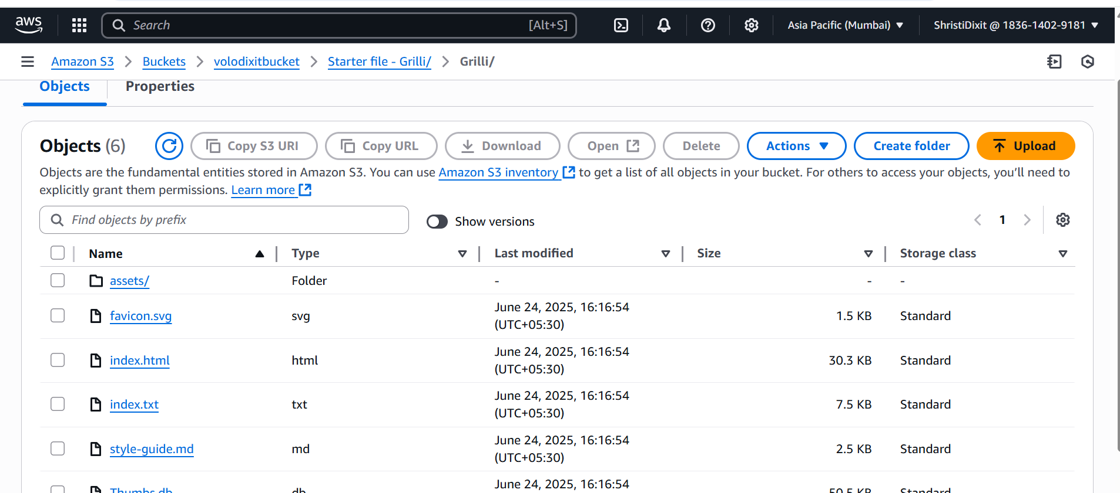

# Step 3: Configure Bucket for Static Website Hosting

1. In the S3 bucket, go to 'Properties'.  
   2. Scroll to 'Static website hosting', click 'Edit'.  
   3. Enable static website hosting.  
   4. Specify index and error documents (e.g., index.html, error.html).  
   5. Save changes.

# Step 4: Make Files Public

Use either of the following methods:

* Option A: Using the Console
* 1. Select all files in your bucket.  
  2. Click 'Actions → Make public'.
* Option B: Set a Bucket Policy

Go to 'Permissions → Bucket policy' and paste the following JSON:

{  
 "Version": "2012-10-17",  
 "Statement": [  
 {  
 "Sid": "PublicReadGetObject",  
 "Effect": "Allow",  
 "Principal": "*",  
 "Action": "s3:GetObject",  
 "Resource": "arn:aws:s3:::volodixitbucket/*"  
 }  
 ]  
}

# Step 5: Access Your Website

Go to 'Properties → Static website hosting'.  
Copy the Bucket website endpoint URL to access your hosted website

# Step 6: (Optional) Use CloudFront for HTTPS + CDN

1. Go to CloudFront → Create Distribution.  
   2. Choose your S3 bucket as the origin.  
   3. Set viewer protocol policy to redirect HTTP to HTTPS.  
   4. Specify 'index.html' as the default root object.  
   5. (Optional) Add your custom domain and attach an SSL certificate via ACM.  
   6. Create distribution and use the provided CloudFront URL to access your site.

[https://volodixitbucket.s3.ap-south-1.amazonaws.com/Starter+file+-+Grilli/Grilli/index.html](https://volodixitbucket.s3.ap-south-1.amazonaws.com/Starter+file+-+Grilli/Grilli/index.html" \o "https://volodixitbucket.s3.ap-south-1.amazonaws.com/Starter+file+-+Grilli/Grilli/index.html)

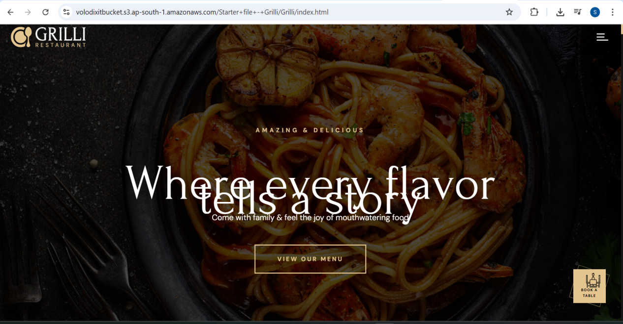

Now you have hosted a website on Amazon S3. This website is available at the Amazon S3 website endpoint. However, you might have a domain, that you want to use to serve the content from the website you created.

Keywords: Keyword 1; Keywords 2; Keyword 3 (use 3-4)

Presentation are communication tools that can be used as demontrations, lectures, reports, and more. it is mostly presented before an audience. Presentation are communication tools that can be used as demontrations, lectures, reports, and more.

1.3 Add a short description